Packet Tracer – Troubleshooting Inter-VLAN Routing

1. Topology

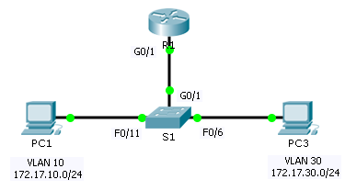

1. Addressing Table

|  |  |  |  |  |  |
| --- | --- | --- | --- | --- | --- |
| Device | Interface | IP Address | Subnet Mask | Default Gateway | VLAN |
| R1 | G0/1.10 | 172.17.10.1 | 255.255.255.0 | N/A | VLAN 10 |
| G0/1.30 | 172.17.30.1 | 255.255.255.0 | N/A | VLAN 30 |
| PC1 | NIC | 172.17.10.10 | 255.255.255.0 | 172.17.10.1 | VLAN 10 |
| PC3 | NIC | 172.17.30.10 | 255.255.255.0 | 172.17.30.1 | VLAN 30 |

1. Objectives

Part 1: Locate Network Problems

Part 2: Implement the Solution

Part 3: Verify Network Connectivity

1. Scenario

In this activity, you will troubleshoot connectivity problems caused by improper configurations related to VLANs and inter-VLAN routing.

1. Locate the Network Problems

Examine the network and locate the source of any connectivity issues.

* Test connectivity and use the necessary **show** commands on to verify configurations.
* List all of the problems and possible solutions in the **Documentation Table**.

1. Documentation Table

|  |  |
| --- | --- |
| Problems | Solutions |
| La interfaz g0/1 esta activa pero la subinterfaz g0/1.10 esta inactiva | Implementar el comando no shutdown para habilitar la subinterfaz g0/1.10 |
| La dirección de puerta de enlace predeterminada (defualt Gateway address)  en Pc3 está configurada incorrectamente | Cambiar la dirección de puerta de enlace (default Gateway) en pc3 de 172.17.10.1 a 172.17.30.1 |
| La interfaz g0/1 en s1 esta configurada como un puerto de acceso trunk (trunk port) | Usar el comando switchport mode trunk para cambiar la interfaz de acceso trunk (access mode trunk) |
| La asignación de Subinterfaces vlan se activan en R1 | Usar el no encapsulation dot1q comando para remover la configuración incorrecta. Luego configurar la subinterface con el encap dot1q vlan comando correcto. |
|  |  |
|  |  |

1. Implement the Solutions

Make changes according to your recommended solutions.

1. Verify Network Connectivity

Verify the PCs can ping other PCs and R1. If not, continue to troubleshoot until the pings are successful.

1. Suggested Scoring Rubric

Packet Tracer scores 60 points. Completing the **Documentation Table** is worth 40 points.